 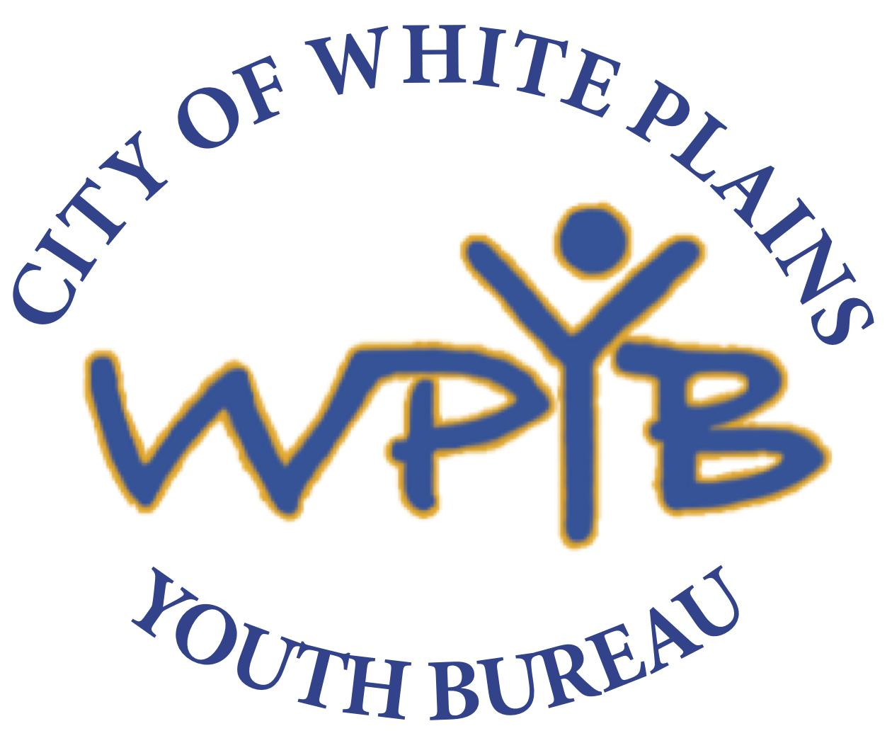

***City of White Plains Youth Bureau***

***Babysitter’s Training******Registration Form***

**Saturday, October 21st - 9:30am- 4pm**

**White Plains Community Center – 65 Mitchell Place**

PLEASE RETURN REGISTRATION FORM PRIOR TO THE TRAINING – SPACE IS LIMITED

For more information or to register

Please call **Janet Spencer (914) 422-2617 or jmspencer@whiteplainsny.gov**

I _____________________________ as parent/guardian of __________________________

agree to the following guidelines in order for my child to participate in the White Plains Youth Bureau Babysitter’s Training program provided by the City of White Plains Youth Bureau.

* I agree to have my child participate in the White Plains Youth Bureau Babysitter’s Training provided by the City of White Plains Youth Bureau being held on **Saturday, October 21st from 9:30am-4pm**
* Once my child has been accepted to participate in the training I will ensure my child’s attendance. If for whatever reason she/he is unable to attend I will contact Janet Spencer at 422-2617 by 5:00 the previous evening of which the training is scheduled.
* I will ensure my child’s prompt arrival. (Please note late arrivals will not be able to gain entrance into the training)
* I agree to send my child with lunch and snacks to the 6 hour training.

Signature of Parent/Guardian: _____________________________ Date:____________

**MEDICAL HISTORY**

***To be completed by parent/guardian***

Is your child’s health generally good? _______________________________________ If not, describe according to chart:

|  |  |  |  |
| --- | --- | --- | --- |
| **Is child subject to:** | **Allergies:** | **Food Allergies:** | **History of Diseases:** |
| ❒Sinus Trouble | ❒Poison Ivy | ❒ Peanuts | ❒ Chicken Pox |
| ❒Ear Infections | ❒Insect Bites | ❒ Other Tree Nuts | ❒ Measles |
| ❒Convulsions | ❒Penicillin | ❒ Other (Please list below) | ❒ German Measles |
| ❒Sleep Walking | ❒Other Medications |  | ❒ Rheumatic Fever |
| ❒Fainting Spells |  |  | ❒ Haemophilus |
| ❒Asthma |  |  | ❒Hepatitis B |
| ❒Hay Fever |  |  | ❒Influenza Type B |

List operations or serious injuries with dates: ___________________________________________________

List chronic or recurring illnesses ______________________________________________________________

Please list current medications _________________________________________________________________

Restrictions on child’s participation in activities _________________________________________________

*Any other issue/concern that we should be aware of*: _________________________________________________

**HOSPITAL RELEASE/PERMISSION SLIP**

Doctor’s Name__________________________________ Phone# ______________________________

In the event of injury, I ___________________________________________________ grant permission to take my child __________________________________________ to a hospital for treatment, to include evaluation of injuries, x-rays and needed care.

Hospitalization Insurance Co. ________________________________________

Identification Number_______________________________________________

**Signature of Parent/Guardian__________________________________ Date______________________**

**CITY OF WHITE PLAINS YOUTH BUREAU**

**September 2023 - June 2024**

PARTICIPATION RELEASE FORM

**Babysitters Training Program**

Name of participant _____

Address Apartment #

City White Plains State NY Zip Code

Birth Date _____ Age _____ Sex ___ Race __________

School Grade _

Parent/ Guardian Name

Child’s E-Mail address ___

Parent’s E-Mail address

Home Phone Parent’s Work Phone

Parent’s Cell Phone _________

Emergency Contact: Name Phone

I, as parent/ legal guardian authorize my child __, to participate in the above activity. This release grants permission for my child to participate in such program.

Parent/Guardian Signature Date

**CITY OF WHITE PLAINS YOUTH BUREAU**

**September 2023- June 2024**

**Release**

Child’s Name: Address:

D.O.B.: Sex: M F

In consideration of your acceptance of my child for his/her participation in the activities/programs of the City of White Plains Youth Bureau, I agree that I am aware of the inherent dangers and risks involved in these activities/programs including bodily injury which may result of strenuous activity or other causes related to these activities/programs. I agree to release and hold harmless the City of White Plains, its officials, officers, agents, employees, and volunteers, from and against any and all liability, damage or claim of any nature arising out of or in any way related to my child=s participation in these activities/programs except those things caused by the sole negligence of the City. I understand that the City of White Plains does not provide accident or medical insurance and I am financially responsible for any and all medical expense whatsoever. I am advised to consult my child’s physician before allowing my child to participate in any strenuous activity. I have read, understand and agree with the terms of this release.

Signature of Parent/Guardian: _________ Date:

I, _______________ , as parent/guardian, hereby consent that the City of White Plains may

videotape/photograph my child, , and use the images/audio for publication/broadcast/website. I waive any claim arising against the City of White Plains from the use of such images/audio within or without the City or any other media.

I understand that the City of White Plains, its employees and volunteers act solely as an agent in arranging for transportation, accommodations, and other services for special events and field trips. The City of White Plains does not assume, and in fact, expressly disclaims, any liability for injury, illness, damage, loss, accident, or delay due to any act, negligence or default of the event/trip guide, or any company or person engaged in transporting the passengers, or rendering any services or accommodations, or carrying out the arrangements for any tour, or their agents, servants, and employees.

I understand that in case of serious injury or illness to my child, I authorize the City Youth Bureau representatives to transfer my child to a hospital or other medical facility for treatment. A reasonable attempt to contact me or my child=s emergency contact will be made. I accept responsibility for all costs involved in the medical transport and treatment of my child.

Signature of Parent/Guardian: ___________ Date: